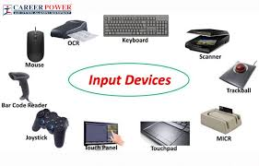**Input devices**

An **input device** is a **hardware component** used

to **enter data or control signals** into a computer.

It allows the user to interact with and provide I

nstructions to the system

The keyboard and mouse are a computer

Most common used or primary input devices

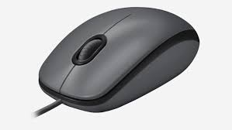

**Mouse**

A **mouse** is a **common input device** used to control

the **movement of the cursor** on a computer screen.

It helps users interact with items like icons, files,

and programs by **pointing, clicking, and dragging**.

**Keyboard**

A **keyboard** is an **input device** used to type text, numbers, and commands into a computer. It’s one of the most common and essential tools for interacting with a computer.

